Step 1:

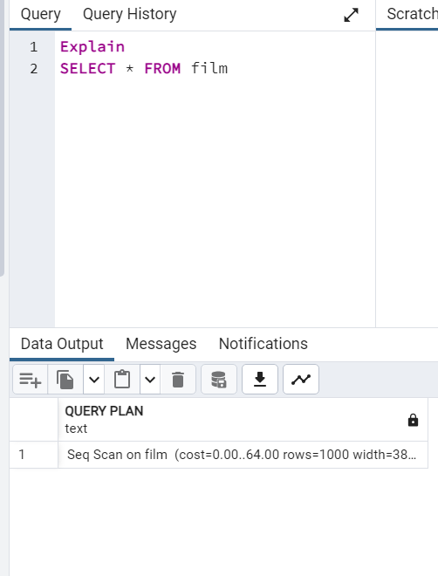

The cost for both Queries is the same even though the columns returned are less. To optimize this we should limit the number of rows that are returned based on aggregation to ensure we are pulling in the necessary data.

Step 2:

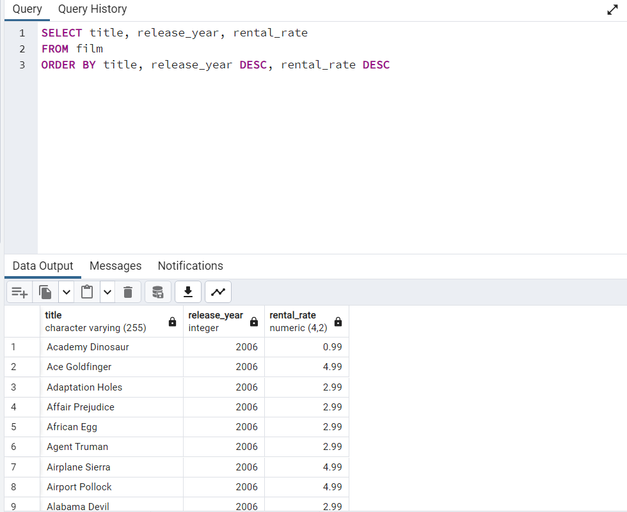

Step 3:

Average Rental Rate

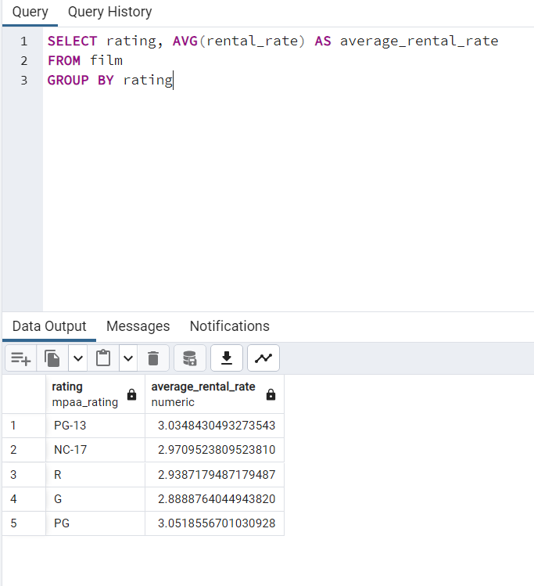

Min and Max Rental Duration

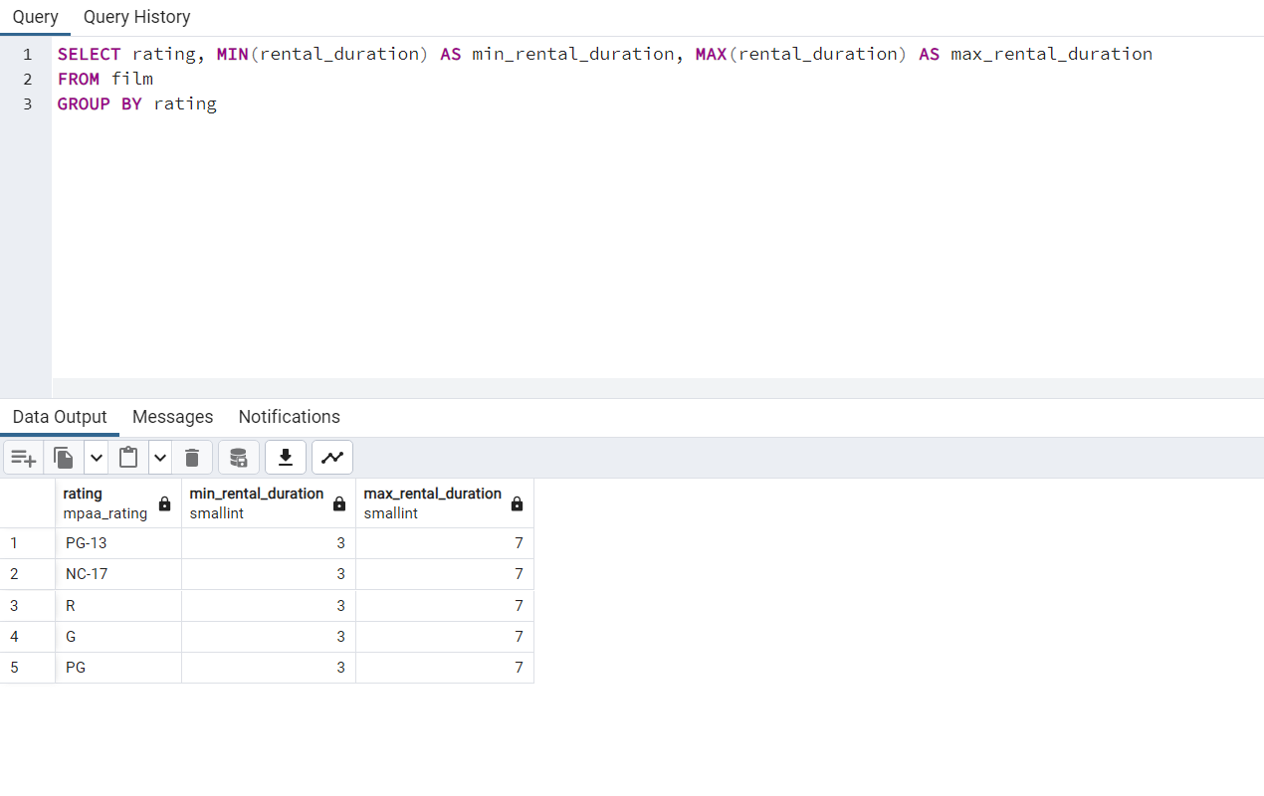

Step 4:

A. Data Engineers would oversee mitigating the data from an external source. They would begin by extracting the data from the android apps which store user data that then can be mitigated and organized into usable data. The usable data would then be used by the data analyst to analyze.

B. Since the data is live it would be continuously updated based on user data and this can cause issues with data integrity for the analysis. By integrity I mean there could be incorrect or even missing data since the data will have to be transferred into the data base from an external source.

Bonus Task

